Rich Rhyme

🔹 What is Rich Rhyme
# Source: Chatgpt (GPT-4-turbo) at [8/1/2025]
A rich rhyme is a type of rhyme that uses homonyms — words that are identical in sound but different in meaning (and sometimes spelling). It is a form of identical rhyme, but specifically exploits the semantic difference between the rhyming words.
The words sound exactly the same but have different meanings (and sometimes different spellings).

🧱 Key Features
# Source: Chatgpt (GPT-4-turbo) at [8/1/2025]
- Pronunciation: Exactly the same
- Spelling: May be the same or different
- Meaning: Different
- Word Class: Can be the same (noun/noun) or different (verb/noun, etc.)

📝 Examples
# Source: Chatgpt (GPT-4-turbo) at [8/1/2025]
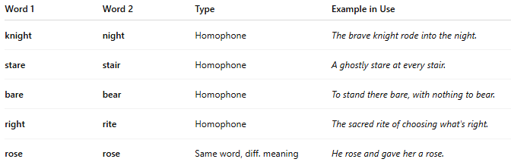
Word 1 | Word 2 | Type | Example in Use
knight | night | Homophone | The brave knight rode into the night.
stare | stair | Homophone | A ghostly stare at every stair.
bare | bear | Homophone | To stand there bare, with nothing to bear.
right | rite | Homophone | The sacred rite of choosing what's right.
rose | rose | Same word, diff. meaning | He rose and gave her a rose.

🎨 Poetic Effect
# Source: Chatgpt (GPT-4-turbo) at [8/1/2025]
- Adds depth through wordplay and double meaning.
- Often used for pun, ambiguity, or witty effects.
- Enhances semantic layering in poems and lyrics.

🗂️ Subcategory Of
# Source: Chatgpt (GPT-4-turbo) at [8/1/2025]
- Identical rhyme, but semantically richer.
- Sometimes overlaps with paronomasia (punning).

⚠️ Not to Be Confused With
# Source: Chatgpt (GPT-4-turbo) at [8/1/2025]
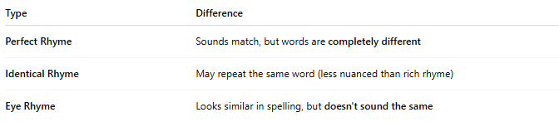
Type | Difference
Perfect Rhyme | Sounds match, but words are completely different
Identical Rhyme | May repeat the same word (less nuanced than rich rhyme)
Eye Rhyme | Looks similar in spelling, but doesn't sound the same

🖋️ Used In
# Source: Chatgpt (GPT-4-turbo) at [8/1/2025]
- Poetry, especially witty or philosophical
- Rap and spoken word
- Limericks and riddles
- Puns and humorous writing

